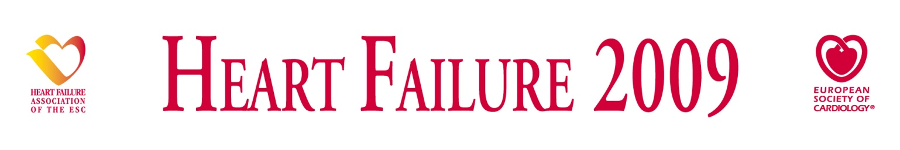

Please sign and return this form by mail or fax to:
The European Heart House
2035 Route des Colles, Les Templiers, BP 179
06903 Sophia Antipolis Cedex, France
Fax: +33-(0)4 92 94 76 20 - E-mail: satellite@escardio.org

Official Sponsorship Opening: 15 June 2008
“First Come, First Served” Policy
Sponsorship deadline: 2 November 2007

SPONSORED SESSIONS APPLICATION & ACCOUNTING FORM

(Tick the appropriate box)

Satellite Symposium Meet the Experts

Satellite Symposium All Inclusive package
Satellite + Room Rental+ 1 Bag Insert, 1 Information Screens Advert and 1 Weblink

ORGANISING COMPANY
Name:
Contact Person:
Address:
Postal code: | City: |  | Country:
Tel: | Fax: | E-mail:
APPOINTED AGENCY (if any)
Name:
Contact Person:
Address:
Postal code: | City: |  | Country:
Tel: | Fax: | E-mail:
Organising Company
Applications for Satellite Symposia and Meet the Experts sessions must be submitted by the company under whose name each session is to be organised. We would like to draw your attention to the fact that the correspondence for the above items should be made exclusively between this company and the ESC.
The company is responsible for communicating any relevant documents to its staff and its appointed agencies.

Appointed Agency
Companies should inform the ESC, in writing, what agency is appointed for which symposia. Otherwise no requests from agencies will be taken into consideration.
This appointed agency cannot fully act as if it were the company itself and the company will continue to be held entirely responsible and accountable for activities organised in its name.
It is not the role of any given agency to make initial enquiries or reservations with the ESC independently of the company.
HF 2009 Sponsored Session Application Form page 1 of 2
SATELLITE SYMPOSIUM (submit one form per Satellite Symposium)
DEADLINE: 03 NOVEMBER 2008
Proposed title:
Duration: 75 or 90 minutes
Preference date: | Saturday, 13 June 2009  14:30 – 16:00 16:30 – 18:00  Sunday, 14 June 2009  12:35 – 13:50* 18:00_19:30  Monday, 15 June 2009  12:35 – 13:50* 18:00 – 19:30  *Companies organising Satellites during the Lunch Time will be allowed to enter in the Lecture Rooms at 12:35 after the scientific session and have to leave the Lecture Rooms at 13:50 in order to let the ESC staff prepare the following scientific session. | Cost:  -Basic price  Lunch or evening session:  € 34.000  -Satellite  All Inclusive Package:  € 41 000  - Room rental included.
Lecture room capacity:
Reception: Yes No
MEET THE EXPERTS SESSION (submit one form per Meet the Experts)
DEADLINE: 03 NOVEMBER 2008
Proposed title:
Duration: 45 minutes
Preference date: | Sunday, 14 June 2009  12:45 – 13:30  Monday, 15 June 2009  12:45 – 13:30 | Cost:  - Basic price: € 18.500  - Room rental included
Lecture room capacity: The attendance cannot exceed 75 persons and must be by invitation only.

ACCOUNTING DATA FORM - the same invoicing address is mandatory for all items -
-
Company or agency to be invoiced: |  |  |  | Your Purchase Order Number:
Contact Person:
Address: |  |  |  |  |  | VAT N°:  Mandatory
Postal code: | City: |  |  |  | Country:
Tel: | Fax: |  | E-mail:
Payment will be made by bank transfer (details will be given on the invoice) or by credit card (please fill in the following information) to ESC.
Visa |  | Euro card / Mastercard |  |  | Amex
Credit Card N°: |  | Expiry Date: |  |  | Cardholder’s name:

Date: | Contact Name: | Signature:
Cancellation Policy: Cancellations of Satellite Symposia should be sent by registered mail to Heart Failure Secretariat. If cancellation is received after the ESC launched the invoicing process and before 17/03/2009, 50% of the total due amount will be charged. If the Satellite Symposium is cancelled after 17/03/2009 date the full compensation fee will be invoiced.
“You have personal data which is, according to the Law on data processing and Civil Liberties 78-17 of 6 January1978, registered with the ESC.
You have the absolute right to access, amend and oppose any use of this personal data by contacting (in writing) the ESC National Society and Member Relations Department at the above-mentioned address.
Unless otherwise informed, the ESC may send you information about its activities from time to time.

HF 2009 Sponsored Session Application Form page 2 of 2

